Cycle Sync Planner

Overview
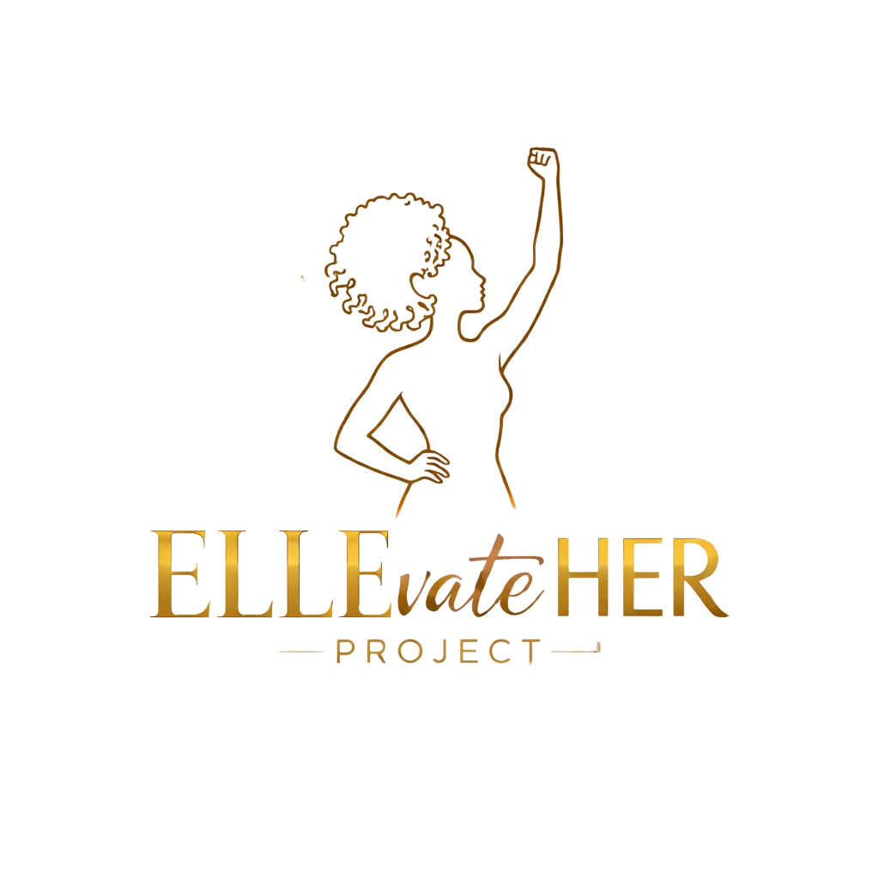
This planner helps you align nutrition, exercise, productivity, and self-care with each phase of your menstrual cycle. Use it weekly to optimize energy, mood, metabolism, and performance.

Phase 1: Menstrual (Days 1–5)
Focus: Rest, restoration, gentle movement
Best Work: Reflection, planning, low-pressure tasks
Exercise: Walking, stretching, yin yoga
Nutrition: Iron-rich foods, warm soups, hydration
Self-care: Sleep, journaling, boundaries

Phase 2: Follicular (Days 6–12)
Focus: Creativity, new projects, high motivation
Best Work: Brainstorming, strategy, starting tasks
Exercise: Cardio, strength training, trying new workouts
Nutrition: Fresh produce, lean protein, probiotics
Self-care: Morning routines, habit building

Phase 3: Ovulatory (Days 13–15)
Focus: Communication, confidence, social tasks
Best Work: Presentations, collaboration, networking
Exercise: HIIT, heavier strength training
Nutrition: High-fiber foods, cruciferous veggies
Self-care: Social connection, confidence rituals

Phase 4: Luteal (Days 16–28)
Focus: Completion, organization, preparation
Best Work: Administrative tasks, finishing projects
Exercise: Strength training ® lower-intensity late luteal
Nutrition: Complex carbs, magnesium-rich foods, B vitamins
Self-care: Stress reduction, early bedtime, decluttering

Educational purposes only. Not medical advice.

Weekly Planner Templates

Daily Intentions
• Energy level: ____________________________________________________________________________________________________________________________________________________________

• Mood check: ____________________________________________________________________________________________________________________________________________________________

• Today’s top 3 priorities:
1. _____________________________________________________________________________
2. _____________________________________________________________________________
3. ______________________________________________________________________________

Nutrition Focus
• Key foods for this phase: ______________________________________________________________________________
• Hydration goal: ______________________________________________________________________________

Movement Plan
• Workout of the day: ______________________________________________________________________________
• Recovery focus: ______________________________________________________________________________

Self-Care
• Stress level (1–10): ______

• Self-care action: ______________________________________________________________________________

Cycle Reflection
• What felt good about this cycle? ______________________________________________________________________________
• What needs adjustment? ______________________________________________________________________________
• Symptoms to track: ______________________________________________________________________________

